Semantic Networks, Frames, and Ontologies
- Semantic networks show relationships, frames organize object information, and ontologies formally define knowledge within a domain.

1. Semantic Networks
Semantic networks represent knowledge as connected concepts and relationships.
Example:
Dog → is-a → Animal
Dog → has → Tail
Purpose: Shows how different concepts are related.

2. Frames
Frames organize information about an object using slots (properties) and values.
Example: Frame for a Dog
Slot | Value
Name | Tommy
Breed | Labrador
Age | 3 years
Colour | Brown
Purpose: Stores structured information about an object.

3. Ontologies
Ontologies formally define concepts, categories, properties, and relationships within a particular domain.
Example: In an animal ontology:
- Dog is a type of animal.
- Animal has properties such as age and habitat.
- Dog may have a relationship with Owner.
Purpose: Helps AI systems understand domain knowledge consistently.

4. Key Differences
Concept | Main Purpose
Semantic Network | Shows connections between concepts
Frames | Stores properties and values
Ontologies | Defines concepts and relationships formally

5. Applications in AI
- Knowledge graphs
- Intelligent search engines
- Natural Language Processing (NLP)
- Virtual assistants
- Knowledge-based systems

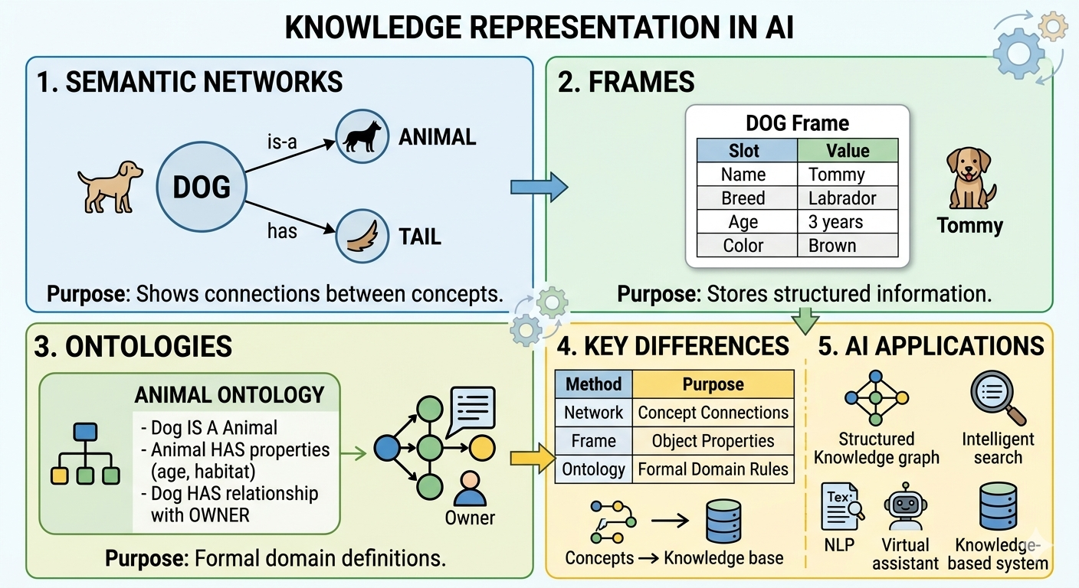

Bayesian Reasoning and Bayesian Networks
- Bayesian reasoning updates probabilities using evidence, Bayes’ theorem provides the mathematical calculation, and Bayesian networks represent probabilistic relationships between variables.

1. Bayesian Reasoning
Bayesian reasoning updates the probability of an event or hypothesis when new evidence becomes available.
Example: If the sky becomes cloudy, we may increase our estimate that it will rain.

2. Bayes’ Theorem
Bayes’ theorem calculates the probability of a hypothesis using prior knowledge and new evidence.
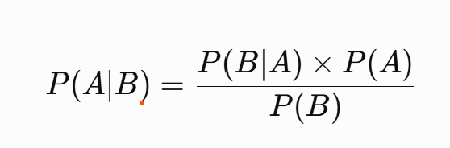
Where:
- Prior probability: Probability of an event before new evidence.
- Likelihood: Probability of observing the evidence if the hypothesis is true.
- Evidence: The observed information.
- Posterior probability: Updated probability after considering the evidence.

3. Bayesian Networks
A Bayesian network represents probabilistic relationships between variables using a directed acyclic graph (DAG).

Example:
Cloud conditions influence the probability of rain.

4. Working Process
- Identify the variables, such as clouds and rain.
- Define their probabilistic relationships.
- Assign probabilities to the variables and relationships.
- Observe new evidence.
- Update the probability of the hypothesis.

5. Example
Suppose the sky is cloudy. A Bayesian system uses historical weather data to estimate the probability of rain. If additional evidence, such as a weather forecast, becomes available, it updates its estimate.

6. Applications in AI
- Medical decision support
- Weather forecasting
- Risk assessment
- Fraud detection
- Prediction and diagnosis

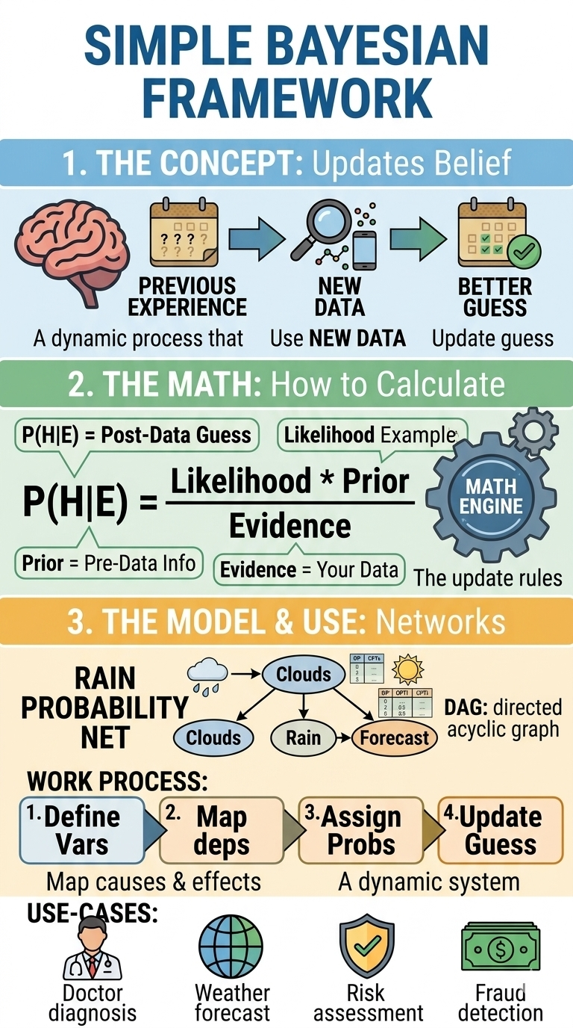

Markov Models, HMMs, and the Viterbi Algorithm
- Markov models predict state changes, HMMs work with hidden states and visible observations, and the Viterbi algorithm identifies the most likely hidden-state sequence.

1. Markov Models
A Markov model predicts the next state based on the current state.
Example: If today's weather is sunny, the model estimates the probability of tomorrow being sunny or rainy.

2. Markov Property
The Markov property states that the next state depends only on the current state, not the entire past history.
Example: Tomorrow's weather prediction uses today's weather state rather than every day's weather history.

3. Hidden Markov Models (HMMs)
An HMM is a statistical model in which the actual states are hidden, but we can observe outputs related to those states.
Example:
- Hidden state: Sunny or rainy weather.
- Observation: A person carries an umbrella or does not carry one.
The weather is the hidden state, while umbrella use is the observable evidence.

4. Key Components of HMMs
- Hidden States: The actual states, such as sunny or rainy.
- Observations: Outputs we can see, such as umbrella use.
- Transition Probabilities: Probabilities of moving from one hidden state to another.
- Emission Probabilities: Probabilities of observing an output given a hidden state.

5. Viterbi Algorithm
The Viterbi algorithm finds the most likely sequence of hidden states based on observed data.
Example: Given several days of umbrella observations, it estimates the most likely sequence of sunny and rainy days.

6. Applications in AI
- Speech recognition
- Natural Language Processing (NLP)
- Biological sequence analysis
- Activity recognition
- Time-series analysis

KDD and AI–Data Mining Integration
KDD is the complete knowledge-discovery process, data mining identifies patterns within that process, and AI helps automate pattern discovery and prediction.

1. Knowledge Discovery in Databases (KDD)
KDD is the overall process of extracting useful knowledge and meaningful patterns from large datasets.
Example: Analysing student records to identify students who may need academic support.

2. Steps in KDD
- Data Selection: Select relevant data, such as attendance and marks.
- Data Cleaning: Remove duplicates and correct missing or incorrect values.
- Data Transformation: Convert data into a suitable format for analysis.
- Data Mining: Apply algorithms to discover patterns.
- Interpretation and Evaluation: Understand the results and check whether they are useful.

3. Data Mining
Data mining discovers useful patterns and relationships in data.
- Classification: Assigns data to categories, such as pass or fail.
- Clustering: Groups similar data, such as students with similar performance.
- Association Rules: Identifies relationships, such as products frequently purchased together.
- Anomaly Detection: Identifies unusual patterns, such as suspicious transactions.

4. AI Integration with Data Mining
AI improves data mining by using machine learning algorithms to discover complex patterns, predict outcomes, and support decisions.
Example: A machine learning model analyses attendance, marks, and assignment records to identify students who may be at risk of poor academic performance.

5. Applications
- Business intelligence
- Fraud detection
- Customer analysis
- Predictive analytics
- Student performance analysis

